Asylum applications in EU+ remain broadly stable despite spike in January

* 12TH MARCH 2019

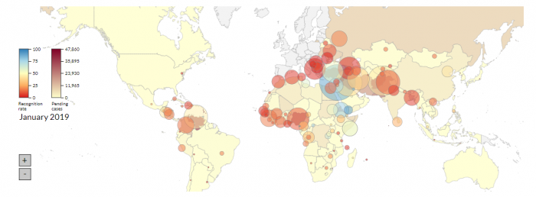

***Despite a higher-than-average number of monthly applications and stock of cases awaiting a first-instance decisions registered in the first month of 2019, figures remain in-line with lower recent trends and fluctuations.***

In the first month of 2019, some 58 600 **applications for international protection** were lodged in the EU+, the second highest number in the past year. While this figure was 21 % higher than that recorded the previous month, it is in-line with annual fluctuations since Decembers are characterised by fewer applications due to festivities. The figure remains broadly aligned to the number of applications in recent months.

In February 2019, [EASO reported](https://www.easo.europa.eu/news-events/eu-asylum-figures-2018-applications-return-2014-levels-decreasing-10-over-previous-year) a 10 % decrease in applications for international protection in 2018 over the previous year, returning to 2014 level.

In January, Syrians, Afghans and Iraqis continued to lodge the most applications. These three nationalities together accounted for 23 % of all applicants in the EU+. Applicants from Pakistan and Venezuela represented an additional 9 %.

Applications by nationals **exempt from visa requirements** when travelling to the Schengen area reached 13 646, a peak since the summer of 2015. Applicants from visa-exempt countries accounted for 24 % of all applications in the EU+. In this group, Venezuelans were the most prominent, and the largest increases took place for three Latin-American states: Venezuela, Colombia and Nicaragua. There were also notable increases for visa-liberalised countries from the EU neighbourhood, mostly for Albania, Moldova and Georgia.

More than 450 000 cases were **awaiting a first-instance decision** at the end of January 2019. This was the largest stock for a year. Just over half of all cases had been pending for longer than six months. The largest share was for nationals from Syria, followed by Venezuela and Afghanistan.

For more information on applications, first-instance decisions, recognition rates, and the stock of cases awaiting a first-instance decision, please consult our analysis and interactive visualisation [here](https://www.easo.europa.eu/latest-asylum-trends).